PRESS RELEASE
FRANCHI UMBERTO MARMI S.P.A.: PARTICIPATION IN THE “NEXT GEMS 2026” CONFERENCE
Milan on Wednesday, 21 October 2026, at Borsa Italiana

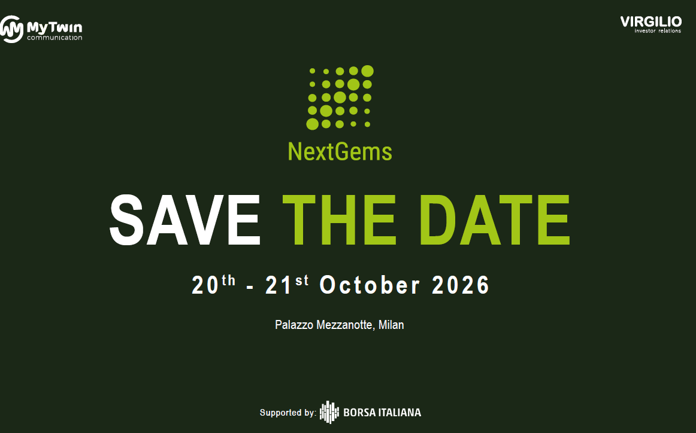

Carrara (Italy), 8 October 2026 – Franchi Umberto Marmi S.p.A., an internationally recognised leader in the “Made in Italy” segment, active in the processing and marketing of high-quality Carrara marble and listed on Euronext Growth Milan (Ticker: FUM) (the “Company”), announces that it will participate in the “NEXT GEMS 2026” CONFERENCE, to be held in Milan on Wednesday, 21 October 2026, at Borsa Italiana.
Carlo Varni, General Manager, and Marco Nannini, CFO of the Company, will attend the event to discuss the Company’s key strategies and latest financial results.

Carlo Varni, General Manager of Franchi Umberto Marmi, commented: “We are pleased to participate in an event that represents an important opportunity for dialogue with the financial community. Against a still challenging backdrop, FUM has demonstrated resilience and strong fundamentals, maintaining robust cash generation and continuing to pursue its growth strategy. Among our most recent initiatives, the new showroom in Miami represents a further step in strengthening our presence in the United States, a strategic market for the Group. At the same time,” Varni concluded, “we continue to invest in the future of Carrara through initiatives such as the Carrara District and the Franchi Academy, with the aim of strengthening international relationships and creating new opportunities for dialogue and development for the local community.”

The event, organised by Virgilio IR and MyTwin, aims to foster dialogue between Italian institutional investors and representatives of selected small and mid-cap companies listed on Borsa Italiana that represent excellence within the Italian listed market.

If you are interested in scheduling an investor meeting, please send an email to: conference@virgilioir.com

***
This press release is available on the Company's website https://www.fum.it/en/investors/price-sensitive-press-release/

***
Franchi Umberto Marmi, established in 1971, is a leader in the processing and marketing of blocks and slabs of Carrara marble, a natural stone that perfectly embodies Italian craftsmanship and luxury, with special characteristics that make it unique in Italy and in the rest of the world. The Company covers all phases of the production and distribution process, thus guaranteeing the absolute quality of the product, whether it is slabs or entire blocks. The activity is mainly concentrated within the 59,000 square meters of the Carrara headquarters, which make it the largest exhibition space dedicated to Carrara marble.

Contacts:
Franchi Umberto Marmi S.p.A.
Via del Bravo n. 14
54033 Carrara (MS)
Tel: +39 0585 70057
investor@fum.it
Corporate website: www.fum.it

Alantra
Euronext Growth Advisor
Tel: +39 3346267243
ega@alantra.com

HEAR-ir
IR & Media Relations
Simona D'Agostino
Tel: +39 335 7729138
simona.dagostino@hear-ir.com
Luca Macario
Tel: +39 335 7478179
luca.macario@hear-ir.com

